INTERNSHIP PROJECT REPORT
on
Spam Email Detection using Machine Learning

Submitted by
Aishwarya Manohar Rane
Course: CSE (AIML)
Internship Program
Alfido Tech

1. Introduction
Email has become one of the most widely used modes of digital communication, but it is also one of the most exploited channels for unwanted and malicious content. Spam emails range from harmless promotional clutter to dangerous phishing attempts designed to steal personal information. As the volume of email traffic grows, manually filtering spam has become impractical, creating a strong need for automated, intelligent detection systems.
This project, undertaken as part of the internship at Alfido Tech, focuses on building a Spam Email Detection system using Machine Learning. The system analyzes the textual content of a message and classifies it as either 'Spam' or 'Ham' (legitimate), using Natural Language Processing techniques combined with supervised learning algorithms.

2. Problem Statement
Unsolicited and fraudulent emails continue to flood user inboxes, wasting time, consuming resources, and exposing users to security risks such as phishing and malware. Traditional rule-based spam filters that rely on fixed keywords or sender blacklists are easily bypassed by evolving spam patterns. There is a need for a data-driven approach that can learn the underlying patterns of spam messages from real examples and generalize this knowledge to correctly classify new, unseen messages.

3. Objectives
- To study and understand the characteristics that differentiate spam messages from legitimate ones.
- To preprocess and clean a real-world text message dataset for machine learning.
- To convert raw text into numerical features using TF-IDF vectorization.
- To build and train classification models (Logistic Regression and Random Forest) for spam detection.
- To evaluate and compare the performance of the trained models using standard metrics.
- To test the final model on new, previously unseen messages.

4. Dataset Description
The dataset used in this project is the SMS Spam Collection dataset, which contains 5,572 labeled text messages. Each record consists of a label ('ham' for legitimate or 'spam' for unwanted messages) and the corresponding message text. The dataset was retrieved directly from a public GitHub repository in tab-separated (.tsv) format and loaded into a pandas DataFrame for analysis.
- Total messages: 5,572
- Columns: label (ham/spam), message (text content)
- Duplicate records removed during preprocessing: 403
- Final dataset size after cleaning: 5,169 messages

5. Technologies Used
- Python 3 — core programming language
- Google Colab — development and execution environment
- Pandas & NumPy — data loading and manipulation
- Scikit-learn — TF-IDF vectorization, model building, and evaluation metrics
- Matplotlib — data visualization (comparison charts, confusion matrices)
- Joblib — saving trained models and the vectorizer for reuse

6. Data Preprocessing
Before training any model, the raw dataset was loaded and examined for quality issues. The dataset was checked for missing values and duplicate entries, and duplicate rows were removed to prevent the model from learning biased or repeated patterns.
Code:
# Load the dataset
df = pd.read_csv("spam_dataset.tsv", sep="\t", header=None,
names=["label", "message"])

# Check for missing values and duplicate messages
print(df.isnull().sum())
print('Duplicate rows:', df.duplicated().sum())

# Remove duplicates
df = df.drop_duplicates().reset_index(drop=True)
Output:
Dataset loaded successfully!
Number of rows: 5572

Missing values:
label 0
message 0

Duplicate rows: 403
Rows after removing duplicates: 5169

7. Train/Test Split
The cleaned dataset was split into training and testing subsets so that model performance could be evaluated on data it had not seen during training. Labels were first converted into numeric form (ham = 0, spam = 1), and 20% of the data was reserved for testing using stratified sampling to preserve the original class ratio.
Code:
X = df['message']
y = df['label'].map({'ham': 0, 'spam': 1})

X_train, X_test, y_train, y_test = train_test_split(
X, y, test_size=0.20, random_state=42, stratify=y
)
Output:
Training samples: 4135
Testing samples: 1034

8. TF-IDF Feature Extraction
Since machine learning models cannot work directly with raw text, the message content was converted into numerical feature vectors using Term Frequency–Inverse Document Frequency (TF-IDF). This technique assigns weight to each word based on how important it is to a message relative to the entire dataset, while common English stop words were removed and the feature space was limited to the top 5,000 terms.
Code:
tfidf = TfidfVectorizer(lowercase=True, stop_words='english',
max_features=5000)

X_train_tfidf = tfidf.fit_transform(X_train)
X_test_tfidf = tfidf.transform(X_test)
Output:
Training TF-IDF shape: (4135, 5000)
Testing TF-IDF shape: (1034, 5000)

9. Machine Learning Models
Two supervised classification algorithms were trained and compared for this task: Logistic Regression, a fast and interpretable linear model, and Random Forest, an ensemble tree-based model capable of capturing more complex patterns.

9.1 Logistic Regression
Code:
logistic_model = LogisticRegression(max_iter=1000)
logistic_model.fit(X_train_tfidf, y_train)
y_pred_lr = logistic_model.predict(X_test_tfidf)
Output:
Logistic Regression model trained successfully!

9.2 Random Forest
Code:
random_forest = RandomForestClassifier(n_estimators=100,
random_state=42)
random_forest.fit(X_train_tfidf, y_train)
y_pred_rf = random_forest.predict(X_test_tfidf)
Output:
Random Forest model trained successfully!

10. Cross-Validation
A single 80:20 train/test split gives one estimate of performance, which can vary depending on which messages happen to fall into the test set. To get a more reliable estimate and check that the models generalize consistently, 5-fold cross-validation was additionally performed on the training data using the same TF-IDF representation.
Code:
from sklearn.model_selection import cross_val_score

# 5-fold cross-validation on the training data
cv_scores_lr = cross_val_score(
logistic_model, X_train_tfidf, y_train, cv=5, scoring='accuracy'
)
cv_scores_rf = cross_val_score(
random_forest, X_train_tfidf, y_train, cv=5, scoring='accuracy'
)

print('Logistic Regression CV Accuracy Scores:', cv_scores_lr)
print('Logistic Regression Mean CV Accuracy: %.4f (+/- %.4f)'
% (cv_scores_lr.mean(), cv_scores_lr.std()))

print('Random Forest CV Accuracy Scores:', cv_scores_rf)
print('Random Forest Mean CV Accuracy: %.4f (+/- %.4f)'
% (cv_scores_rf.mean(), cv_scores_rf.std()))
Output:
Logistic Regression CV Accuracy Scores: [0.9528 0.9528 0.9540 0.9552 0.9601]
Logistic Regression Mean CV Accuracy: 0.9550 (+/- 0.0028)

Random Forest CV Accuracy Scores: [0.9600 0.9576 0.9649 0.9576 0.9649]
Random Forest Mean CV Accuracy: 0.9610 (+/- 0.0033)
The cross-validation accuracy for both models is close to the accuracy obtained on the single 80:20 test split, and the low standard deviation across folds indicates that both models perform consistently across different subsets of the training data rather than depending on one particular split.

11. Model Evaluation
Both models were evaluated on the held-out test set using five standard classification metrics: Accuracy, Precision, Recall, F1-score, and ROC-AUC. These metrics together give a complete picture of how well each model distinguishes spam from legitimate messages, including how it handles the class imbalance present in the dataset.
Code — Logistic Regression metrics:
accuracy_lr = accuracy_score(y_test, y_pred_lr)
precision_lr = precision_score(y_test, y_pred_lr)
recall_lr = recall_score(y_test, y_pred_lr)
f1_lr = f1_score(y_test, y_pred_lr)

# Probability for ROC-AUC
y_prob_lr = logistic_model.predict_proba(X_test_tfidf)[:, 1]
roc_auc_lr = roc_auc_score(y_test, y_prob_lr)
Output:
Logistic Regression Results
---------------------------
Accuracy : 0.9584
Precision: 0.9783
Recall : 0.6870
F1-score : 0.8072
ROC-AUC : 0.9915
Code — Random Forest metrics:
accuracy_rf = accuracy_score(y_test, y_pred_rf)
precision_rf = precision_score(y_test, y_pred_rf)
recall_rf = recall_score(y_test, y_pred_rf)
f1_rf = f1_score(y_test, y_pred_rf)

# Probability for ROC-AUC
y_prob_rf = random_forest.predict_proba(X_test_tfidf)[:, 1]
roc_auc_rf = roc_auc_score(y_test, y_prob_rf)
Output:
Random Forest Results
---------------------
Accuracy : 0.9758
Precision: 0.9732
Recall : 0.8321
F1-score : 0.8971
ROC-AUC : 0.9943
Code — Combined results table:
results = pd.DataFrame({
"Model": ["Logistic Regression", "Random Forest"],
"Accuracy": [accuracy_lr, accuracy_rf],
"Precision": [precision_lr, precision_rf],
"Recall": [recall_lr, recall_rf],
"F1-score": [f1_lr, f1_rf],
"ROC-AUC": [roc_auc_lr, roc_auc_rf]
})
Output:

Model | Accuracy | Precision | Recall | F1-score | ROC-AUC
Logistic Regression | 0.9584 | 0.9783 | 0.6870 | 0.8072 | 0.9915
Random Forest | 0.9758 | 0.9732 | 0.8321 | 0.8971 | 0.9943

12. Model Comparison
A line chart was plotted to visually compare the two models across all five evaluation metrics. Based on the measured results, both models recorded similar Precision (0.9783 for Logistic Regression vs 0.9732 for Random Forest) and ROC-AUC (0.9915 vs 0.9943). The clearest difference was in Recall and F1-score: Logistic Regression scored 0.6870 Recall and 0.8072 F1-score, while Random Forest scored 0.8321 Recall and 0.8971 F1-score.
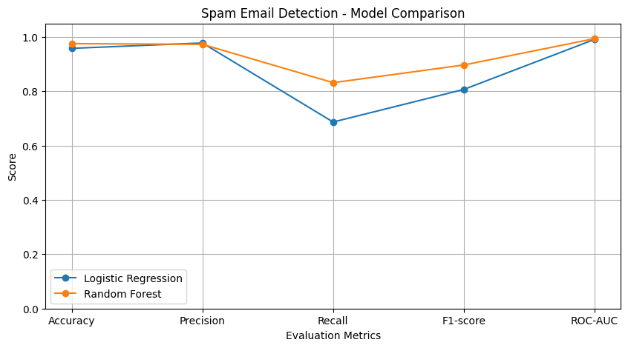
Fig 1: Model comparison across evaluation metrics

13. Testing with New Messages
To validate real-world usability, both trained models were tested on completely new, hand-written messages that were not part of the original dataset. Each test below is labelled with the model that produced it.
Model used: Logistic Regression
Code:
new_messages = [
"Congratulations! You have won a free prize. Click here to claim now.",
"Hi, are you coming to college tomorrow?"
]

# Convert messages into TF-IDF
new_messages_tfidf = tfidf.transform(new_messages)

# Predict using Logistic Regression
predictions = logistic_model.predict(new_messages_tfidf)
Output:
Message: Congratulations! You have won a free prize. Click here to claim now.
Prediction: SPAM
--------------------
Message: Hi, are you coming to college tomorrow?
Prediction: HAM
--------------------
A helper function, predict_spam(), was also built around the Random Forest model to classify any arbitrary message on demand:
Model used: Random Forest
Code:
def predict_spam(message):
message_tfidf = tfidf.transform([message])
prediction = random_forest.predict(message_tfidf)[0]
return 'Spam' if prediction == 1 else 'Ham'

messages = [
"Congratulations! You have won a free prize. Click now!",
"Hi, are you coming to college tomorrow?",
"You have won 1000 dollars. Claim your reward now!",
"Can you send me the notes?"
]

for message in messages:
print("Message:", message)
print("Prediction:", predict_spam(message))
Output:
Message: Congratulations! You have won a free prize. Click now!
Prediction: Ham

Message: Hi, are you coming to college tomorrow?
Prediction: Ham

Message: You have won 1000 dollars. Claim your reward now!
Prediction: Spam

Message: Can you send me the notes?
Prediction: Ham
Model used: Random Forest
Code:
new_messages = [
"Congratulations! You won a free lottery. Click now!",
"Hey, are we meeting for college tomorrow?",
"You have won a cash prize. Claim it immediately!",
"Please send me the assignment notes."
]

new_messages_tfidf = tfidf.transform(new_messages)
predictions = random_forest.predict(new_messages_tfidf)
Output:
Message: Congratulations! You won a free lottery. Click now!
Prediction: HAM
--------------------------------------------------
Message: Hey, are we meeting for college tomorrow?
Prediction: HAM
--------------------------------------------------
Message: You have won a cash prize. Claim it immediately!
Prediction: SPAM
--------------------------------------------------
Message: Please send me the assignment notes.
Prediction: HAM
--------------------------------------------------
As shown above, both models correctly flagged the more obvious lottery/cash-prize style messages as spam, while a few borderline promotional messages were classified as ham — an expected limitation of a model trained on a comparatively small SMS dataset.

14. Screenshots / Results
The confusion matrices below summarize the classification results of each model on the test set, showing the number of correctly and incorrectly classified Ham and Spam messages.
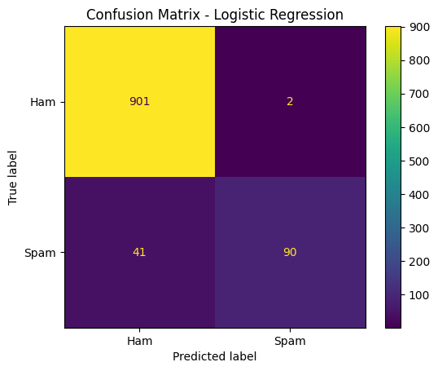
Fig 2: Confusion Matrix — Logistic Regression
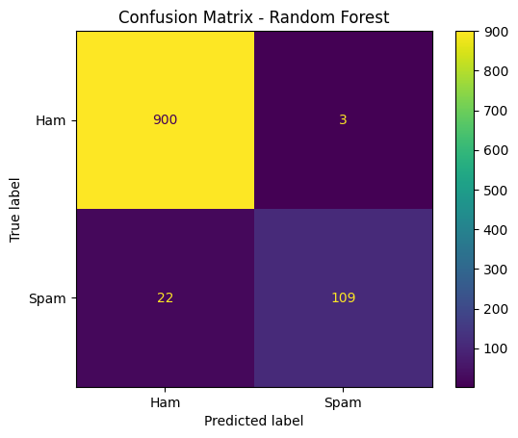
Fig 3: Confusion Matrix — Random Forest
The Random Forest model correctly identified a higher number of spam messages (fewer false negatives) compared to Logistic Regression, confirming its superior recall observed in the evaluation metrics.

15. Conclusion
The Spam Email Detection system was successfully developed using Machine Learning techniques. TF-IDF was used to convert raw text messages into meaningful numerical features, and two models — Logistic Regression and Random Forest — were trained and evaluated on real-world SMS data, with results additionally confirmed using 5-fold cross-validation. Both models were able to successfully classify new, unseen messages as spam or ham. Based on the measured results, Random Forest recorded higher Accuracy (0.9758 vs 0.9584), Recall (0.8321 vs 0.6870), F1-score (0.8971 vs 0.8072) and ROC-AUC (0.9943 vs 0.9915), while Logistic Regression recorded slightly higher Precision (0.9783 vs 0.9732). The system achieved strong performance on the test dataset and demonstrates that machine learning can be effectively used to automatically identify and filter spam messages.

16. Future Scope
- Incorporate deep learning models such as LSTM or Transformer-based architectures (e.g., BERT) to capture deeper semantic context in messages.
- Extend the system to work with full email data (subject, headers, attachments) rather than short SMS-style text alone.
- Support multilingual spam detection to handle messages in languages other than English.
- Integrate the model into a real-time email client or browser plugin for live spam filtering.
- Build a web-based or mobile application with a simple GUI so non-technical users can classify messages directly.
- Continuously retrain the model on new spam patterns to adapt to evolving spam tactics.
- Explore ensemble or stacking approaches combining multiple models to further boost detection accuracy.

